main website

Logo |  | BforC Careers | About us | Member benefits | Pricing plans

Hero section
[photo]

Providing global solutions to local problems
Brains for Compassion is a women-led organisation that works towards women's empowerment through life-skill training, supporting women’s careers, raising awareness, and providing opportunities.
Find your passion with BforC careers →

Benefits
As a BforC member, you become a part of our empowered community.

When you sign up as a member, BforC will support you with:

- Access to job listings
Get access to hand-picked job listings through the BforC Careers portal and start your professional journey. We have opportunities for women in every walk of life.
- BforC club membership
Get access to networking opportunities with the founders group and fellow BforC members in your location. Become a part of our regular networking meetings and avail shopping and travel benefits.
- Entrepreneurship guidance and funding
For women who are starting their own ventures, BforC provides guidance and seed funding to support budding ideas. New businesses and entrepreneurs can get funds and a chance at incubation.
- Health and wellness benefits
Get life skills coaching and training, and participate in meditation sessions with fellow BforC members. We believe in supporting your mental well-being at all times.
- Global connections
Get connected to a rich network of amazing women across the globe and make connections that will last a lifetime. BforC provides all women a platform for making strong and meaningful connections.

View all member benefits →

Testimonials
[take from the main website; add new testimonials]

Our partners
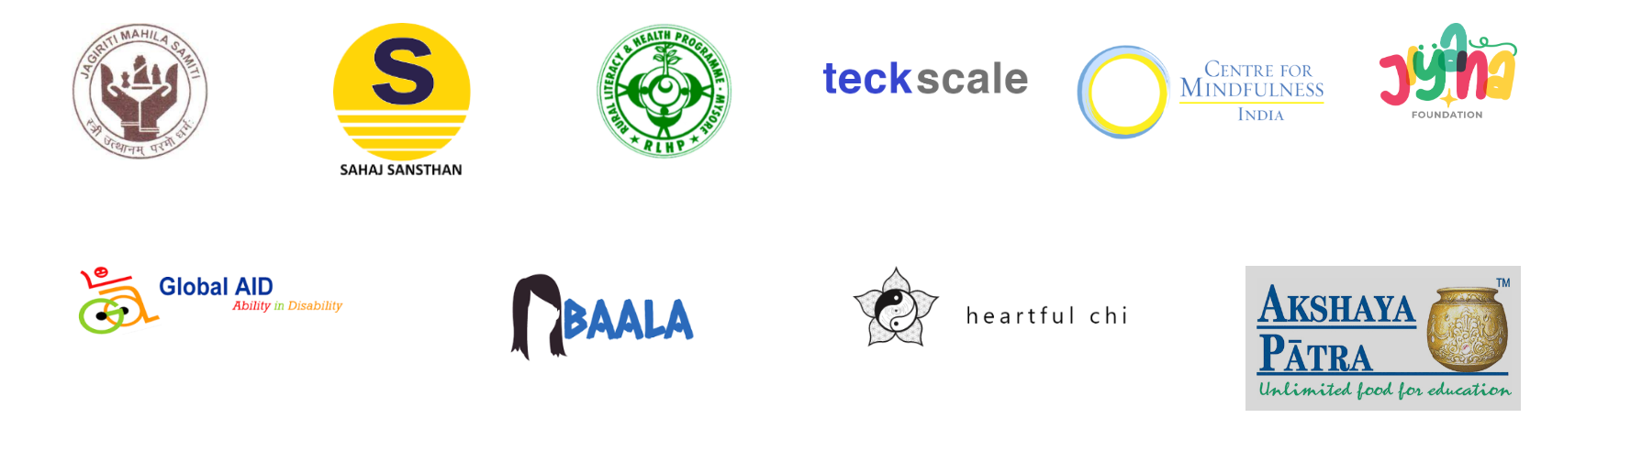

Footer
About Us  “Brains for Compassion is an all-women organisation with a strong focus on supporting like-minded organisations to bring a positive change across the globe.” | Our Office:  F6, Mahaveer Nagar,  Pal Link Road  Behind Kamla Nagar  Hospital  Jodhpur, Rajasthan | Contact Us  varsha@bforc.org  jyothi@bforc.org  +91 9461992263  Facebook link  Instagram link  LinkedIn link
 | Logo | All rights reserved  Terms of use  Privacy and cookie policy

ABOUT US
(same page as About BforC linked from the career website)

Brains for Compassion (BforC) is a fully women-led organisation that serves as a strong catalyst for change by partnering with like-minded organisations and institutions, striving to make a positive impact in communities. Women from different parts of the world have joined hands and are working with BforC to bring their knowledge and skills together to provide global solutions to local problems.

BforC has been successfully working for positive impact and growth since March 2020. Our mission is to bring together the best practices for strengthening the positive impact around the world, while simultaneously creating an equal space for both men and women.

Vision  “All individuals learn, contribute & grow equally for the elevation of the world.” | Mission  “To introduce the best practices for strengthening the positive impact around the world.” | Purpose  “Bestow wisdom and knowledge through a participatory approach.”

Our Values

- BELIEVING IN EVERYONE
We believe that great and innovative ideas can come from anyone and everyone. We welcome all unique and motivated individuals to join us!
- MAINTAINING UNITY & INTEGRITY
Sticking and working together is the key to the success of a good organisation, and we pride ourselves on maintaining our integrity.
- DOING WHAT THE HEART SAYS
Limiting our ideas only holds us back. We believe in doing what our hearts say to bring about the right and positive changes in the world.
- EMBRACING KNOWLEDGE & WISDOM
We are always on a hunt for knowledge and ideas, ready to learn and accept all wisdom! We believe that we all can learn something new every day.
- BEING ETHICAL & TRUTHFUL
Being ethically correct and true to our cause is one of our greatest values at BforC. We believe in always standing up for what is morally right.

MEMBER BENEFITS

By signing up with us as a BfroC community member, you will become a valued member of the BforC Club, an empowered group of like-minded and passionate women.

- Get access to job listings
The BforC career portal provides a platform to all job-seeking women who are looking to start their careers, grow professionally, or even return to work after a break. We understand everyone’s situation and take care of every woman’s career needs. Whether you want remote work, flexible schedules, training, or more, BforC offers opportunities of all kinds.
Visit BfroC career portal →
- BforC Club membership
As a BforC club member, you will become a part of a tight-knit community with the following benefits:
  - Network and connect with the BforC founders group and grow your contacts.
  - Engage with like-minded community members residing locally in your city and build a close, supportive community.
  - Get various kinds of benefits on products, shopping, and travel.
  - Get an opportunity to attend BforC’s quarterly networking meetings where you can connect with like-minded, empowered women.
- Entrepreneurship guidance and funding
BforC provides guidance, training, and seed funding to support all women with budding ideas. If you are an entrepreneur who is starting your own business, organization, or venture, BforC will support your efforts through necessary funds and a chance at incubation.
- Health and wellness benefits
BforC cares about every strong woman who gets associated with us. As a BforC member, you will be able to get life skills coaching and training, contributing to your upliftment. Along with that, BforC also facilitates meditation and wellbeing sessions with fellow BforC members so that you always feel your best!
- Global connections
BforC is a rapidly growing community of amazing women. As a member, you get to connect with a rich network of women across the globe and make connections that will last a lifetime. BforC provides all women a platform for making strong and meaningful connections.

Become a member now →

PRICING PLANS

Individual member onboarding

As a BforC member, you will get:
- All member benefits.
- An all-event pass for every BforC-organized event.
- Opportunity to go on a trip of empowerment, a community service trip to impactful NGOs.

For professionals  Rs. 5000 per year  Rs. 1250 quarterly payment option available. | For students  Rs. 3000 per year

For organizations

Rs. 50,000
for onboarding 50 candidates.

PROGRAMS AND SERVICES

Our ongoing programs

- LIFESKILL TRAINING
Experiential learning camps
- GLOBAL TO LOCAL
Volunteering and internships
- PROJECT HAUSHALA
Technology and innovation
- PROJECT AZADI (FREEDOM)
Make menstruation easy
- ADOPT A GRANNY
Support who supported us

What we offer

- Project Strategy & Development
  - Need assessment
  - Situational analysis & baseline studies
  - Market research & feasibility studies
  - Competitor analysis
  - Programmatic and donor engagement
- Training & Development
  - Lifeskills (Experiential learning)
  - Recruitment (Finding the best fit to achieve the organisational goal)
  - Staff capacity development
  - Adolescent camps
  - Support and advocate for women’s rights
- Program Management
  - Program design
  - Grantmaking
  - Nonprofit due diligence
  - Capacity building
  - CSR and employee engagement
  - Impact investing
  - Campaign for social cause
- Impact Assessment/ROI
  - Monitoring and evaluation
  - Metrics reporting and dashboard creation
  - Program communication and reporting
  - Site visits and donor trips
- Reporting & Development
  - Creation and management pooled philanthropic funds
  - Events, covenings and webinars
  - Partnership strategies
  - Funding mechanism and vehicles to facilitate donor partnership
  - Content writing (for website, projects, events, programs, proposals, and success stories/case studies)
- Networking & Communication
  - Strategy and planning services for major donor engagement
  - Research and analysis on the donor landscape and prospective donors
  - Donor engagement messaging and marketing materials Fundraising support

career portal content

Career website

[1] Landing page ✓
- [2] User view after login ✓
  - [3] Find a role ✓
  - [4] View plans
- [5] Employer view after login
  - [6] Post a job
- Footer
  - [7] About BforC ✓
  - [8] Our partners
  - [9] Contact
  - [10] Legal documents

LANDING PAGE

Logo | Find a role | Find talent | Login/Signup

WHERE COMPASSION MEETS CAREERS

Rebuild your career. Fuel your dreams.

Find roles in social impact, NGOs, and purpose-driven organisations, and become a part of a community. Women-friendly workplaces. Real opportunities.
2400+
Women Placed
340+
Active Roles
18
Countries

— EXPLORE BY TYPE —

Find roles made specifically for you.
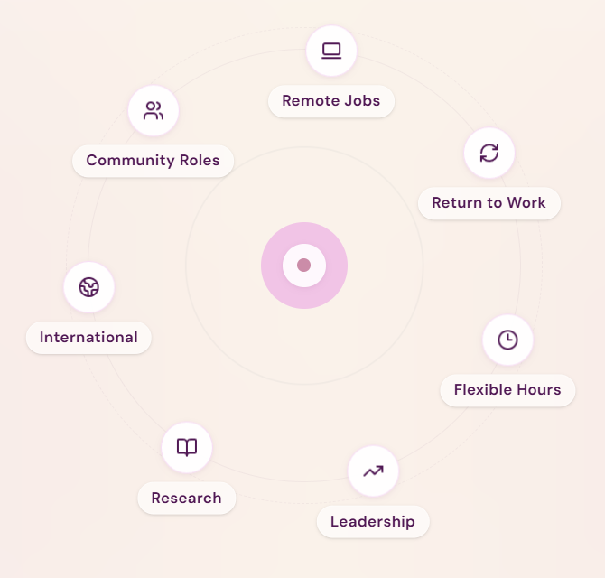

— FEATURED ROLES —

Find your passion and purpose.
Browse all roles ->
Button: View all opportunities ->

— FEATURED ORGANIZATIONS —

Work with teams that care.
Button: View all organizations ->

Are you an organisation that works for impact?
Join our curated network of NGOs and social enterprises to find passionate, purpose-driven talent.
Button: Create Employer Profile ->

— WHY BFORC CAREERS — [remove]
BforC Careers is built differently.
BforC is built for you.
We are not just another job board. We empower women in social impact and help them rebuild. BforC is a community of like-minded, strong, independent women doing impactful work for positive change. We close the gap between talented women and meaningful organizations, bringing them closer to the opportunities they deserve, and transforming career paths for women excluded from the workforce.

Women-Friendly Ratings
All onboarded organizations are rated on maternity policies, flexibility, pay equity, and safety. BforC advocates for companies that foster an empathetic work environment.

AI Resume Parsing
Upload your resume and auto-create your BforC Careers profile. Apply to roles in under 2 minutes from anywhere, any time, even from your phone.

Verified Employers Only
Every organisation on BforC Careers is verified. No fake listings and no misleading. We value and respect your time and efforts.

— SUCCESS STORIES —

Stories that move us forward

—---

Footer

BforC Careers
A women-led platform where compassion meets careers. Working on connecting skilled talent with purpose-driven organisations that work for social impact.

For Job Seekers  - Find a role  - View plans  - Resume Upload | For Employers  - Post a Job  - Talent Search  - Employer Plans | Company  - About BforC  - Our services  - Our Partners  - Contact | Legal  - Privacy Policy  - Terms of Service  - Anti-Harassment

USER VIEW AFTER LOGIN

Logo |  |  | Find a role | Profile

WHERE COMPASSION MEETS CAREERS

Rebuild your career. Fuel your dreams.

Find roles in social impact, NGOs, and purpose-driven organisations, and become a part of a community. Women-friendly workplaces. Real opportunities.
2400+
Women Placed
340+
Active Roles
18
Countries

— EXPLORE BY TYPE —

Find roles made specifically for you.


— FEATURED ROLES —

Find your passion and purpose.
Browse all roles ->
Button: View all opportunities ->

— FEATURED ORGANIZATIONS —

Work with teams that care.
Button: View all organizations ->

— WHY BFORC CAREERS — [remove]
BforC Careers is built differently.
BforC is built for you.
We are not just another job board. We empower women in social impact and help them rebuild. BforC is a community of like-minded, strong, independent women doing impactful work for positive change. We close the gap between talented women and meaningful organizations, bringing them closer to the opportunities they deserve, and transforming career paths for women excluded from the workforce.

Women-Friendly Ratings
All onboarded organizations are rated on maternity policies, flexibility, pay equity, and safety. BforC advocates for companies that foster an empathetic work environment.

AI Resume Parsing
Upload your resume and auto-create your BforC Careers profile. Apply to roles in under 2 minutes from anywhere, any time, even from your phone.

Verified Employers Only
Every organisation on BforC Careers is verified. No fake listings and no misleading. We value and respect your time and efforts.

— SUCCESS STORIES —

Stories that move us forward

—---

Footer

BforC Careers
A women-led platform where compassion meets careers. Working on connecting skilled talent with purpose-driven organisations that work for social impact.

For Job Seekers  - Browse Jobs  - Pricing  - Resume Upload | Company  - About BforC  - Our services  - Our Partners  - Contact | Legal  - Privacy Policy  - Terms of Service  - Anti-Harassment

FIND A ROLE

Find your purpose.
Browse through multiple open roles at purpose-driven organizations and institutions to find the perfect fit for you. Find opportunities in social impact and work to bring about positive change.

EMPLOYER VIEW AFTER LOGIN

Employer Dashboard
Manage your listings and review interested applicants.

For Employers

Find the right talent
Select from our curated pool of purpose-driven talented women. BforC supports your hunt for suitable, academically-trained professionals who are ready to work from day one!

Request full access -->

7. ABOUT BFORC
(same page as About Us linked from the main website)

Brains for Compassion (BforC) is a fully women-led organisation that serves as a strong catalyst for change by partnering with like-minded organisations and institutions, striving to make a positive impact in communities. Women from different parts of the world have joined hands and are working with BforC to bring their knowledge and skills together to provide global solutions to local problems.

BforC has been successfully working for positive impact and growth since March 2020. Our mission is to bring together the best practices for strengthening the positive impact around the world, while simultaneously creating an equal space for both men and women.

Vision  “All individuals learn, contribute & grow equally for the elevation of the world.” | Mission  “To introduce the best practices for strengthening the positive impact around the world.” | Purpose  “Bestow wisdom and knowledge through a participatory approach.”

Our Values

- BELIEVING IN EVERYONE
We believe that great and innovative ideas can come from anyone and everyone. We welcome all unique and motivated individuals to join us!
- MAINTAINING UNITY & INTEGRITY
Sticking and working together is the key to the success of a good organisation, and we pride ourselves on maintaining our integrity.
- DOING WHAT THE HEART SAYS
Limiting our ideas only holds us back. We believe in doing what our hearts say to bring about the right and positive changes in the world.
- EMBRACING KNOWLEDGE & WISDOM
We are always on a hunt for knowledge and ideas, ready to learn and accept all wisdom! We believe that we all can learn something new every day.
- BEING ETHICAL & TRUTHFUL
Being ethically correct and true to our cause is one of our greatest values at BforC. We believe in always standing up for what is morally right.

blueprint
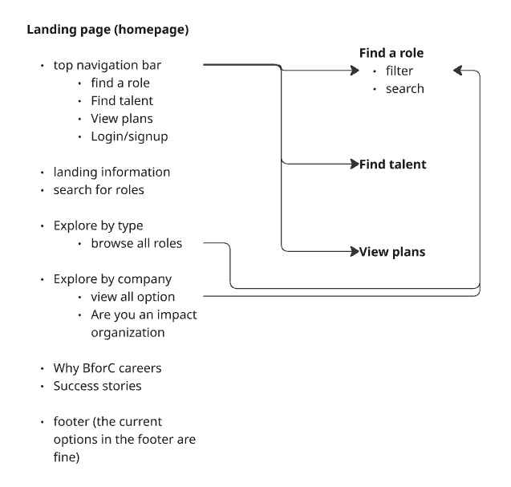Here’s a complete, practical Business Model Canvas tailored for Brains for Compassion (BforC) as a social enterprise career ecosystem for women—not just a job portal.

🧩 BFORC – BUSINESS MODEL CANVAS
Positioning:
“Career rebuilding ecosystem for underserved women”

🔹 1. Customer Segments
🎯 Primary Beneficiaries (Users)
- Women returning after career break
- Semi-skilled / underprivileged women
- Rural & tier 2–3 women
- First-time job seekers
- Women needing flexible / part-time work
💼 Paying Customers
- SMEs & corporates (diversity hiring)
- CSR foundations
- NGOs & skilling partners
- Impact investors / donors

🔹 2. Value Proposition
For Women:
- “From no confidence → job readiness → income”
- Safe, verified, flexible job opportunities
- Handholding via Career Saathi
- Skilling + placement + retention support
For Employers:
- Pre-screened, reliable women talent
- Reduced hiring risk
- Diversity hiring solutions
- Retention support (lower attrition)
👉 Unlike Naukri.com or LinkedIn, BforC solves access + readiness + retention, not just hiring.

🔹 3. Channels
- Mobile-first platform (low-bandwidth friendly)
- WhatsApp onboarding & engagement
- NGO & SHG (Self Help Group) networks
- Community centers / local hubs
- Social media (Instagram, YouTube)
- CSR & corporate partnerships

🔹 4. Customer Relationships
Women:
- High-touch support (mentors / Career Saathi)
- Community groups (peer support)
- Continuous engagement (not one-time placement)
Employers:
- Dedicated relationship manager
- Talent curation support
- Post-placement follow-up

🔹 5. Revenue Streams (Hybrid Model)
💰 Earned Revenue:
- Placement fees (8–15% of CTC)
- Subscription plans for employers
- Skilling program fees (B2B / B2G funded)
- Commission on gig/micro-work (5–20%)
🤝 Impact Funding:
- CSR grants (women livelihood, skilling)
- Government schemes
- International donors
👉 Balance impact + sustainability (not donation-dependent)

🔹 6. Key Activities
- Talent sourcing (NGOs, communities)
- Women Readiness Assessment (your IP)
- Skilling & training programs
- Job matching & placement
- Employer onboarding
- Mentorship & retention support
- Platform development & management

🔹 7. Key Resources
- Technology platform (app/portal)
- BforC network (NGOs, volunteers)
- Employer network
- Training content & curriculum
- Career Saathi / mentors
- Brand credibility in social impact

🔹 8. Key Partnerships
- NGOs & grassroots organizations
- CSR arms of companies
- Skill development agencies
- Government programs (NRLM, Skill India)
- Women SHGs & community leaders
- EdTech platforms for content

🔹 9. Cost Structure
Fixed Costs:
- Tech development & maintenance
- Core team salaries
- Platform operations
Variable Costs:
- Training delivery
- Field outreach
- Marketing & awareness
- Mentor incentives
- Community hub costs

🔥 BFORC UNIQUE MODEL (Your Differentiator)
💡 “CAREER PIPELINE APPROACH”
Stage 1: Identify
- Women via NGOs / communities
Stage 2: Assess
- Readiness Score (skills + confidence + constraints)
Stage 3: Build
- Skilling + mindset + digital literacy
Stage 4: Place
- Jobs / gigs / micro-work
Stage 5: Sustain
- 90-day handholding (Career Saathi)
👉 Most platforms stop at Stage 4.
👉 Your power is Stage 5 (retention + dignity)

📊 IMPACT METRICS (Critical for Funding)
- Number of women onboarded
- % women placed
- Income increase
- Job retention (3–6 months)
- Women entering workforce first time
- Women restarting careers

⚡ SCALABILITY STRATEGY
Phase 1 (0–6 months)
- Pilot in 1–2 cities
- Focus on 2 sectors (e.g., admin, digital jobs)
Phase 2 (6–18 months)
- Expand via NGO partnerships
- Build strong employer base
Phase 3 (18+ months)
- Scale pan-India
- Launch multilingual platform

🚨 RISKS (AND HOW YOU HANDLE THEM)
Risk | Solution
Women drop out | Career Saathi support
Employer trust issues | Pre-screening + training
Low digital literacy | WhatsApp + assisted onboarding
Revenue delays | Mix CSR + earned income

🎯 FINAL POSITIONING LINE
👉 “BforC is not a job portal. It is a career transformation platform for women excluded from the workforce.”

If you want next step, I can:
- Turn this into a pitch deck (10 slides for CSR funding)
- Create a financial model (3-year revenue projection)
- Or design your actual platform structure (features + user flow)

